
Customer’s and Employee’s Management in Mayo-Clinic and Cleveland-clinic

Final Assignment Submitted to

Dr Esyin Chew

Department of Information Technology Management
By

Chidubem Ogechukwu Madubuko

ST20207148

December 2021

BIOGRAPHY
As a Healthcare business analyst, I collected and interpreted data from a variety of sources to assist organisation in improving the standard of care, promoting a cost-effective care option, and improving the patient experience. Responsible for presenting data to assist hospital executives and other in understanding the operational impact of the data. In addition, I effectively used my understanding of data collecting, management, analysis, and evaluation to healthcare data, delivering meaningful insights for physicians, clinical researchers, and others.

ABSTRACT
Purpose
The purpose of this study is separated into two sections. The first step is to look at the customer/patient review data from social media for Mayo Clinic and Cleveland Clinic. These numbers were scraped and visualised. Employee evaluations, on the other hand, were scraped and visualised. In general, each clinic's customer and employee management should be understood. Furthermore, Twitter data from both Clinics were employed in sentiment analysis to monitor their data.

Design/methodology/approach
The data science project is mostly used to analyse the study structure. To visualise Yelp, Indeed, and Twitter social media data, different tools API were utilised. The visual data been utilised will be used to draw conclusions and make recommendations for customer and employee management for both Clinics in the future.
Findings
The findings shows that Mayo Clinic and Cleveland Clinic both need to improve their Customer Relationship Management (CRM) skills; there is a significant gap in CRM understanding, despite some favourable feedback. The Employees management on the other hand, it implies that the world of health-care staffing is complicated and diverse. Also, the ramifications of staffing are far-reaching, affecting practically every area of healthcare.
Social or Business implications
The findings of the study can be used by both clinics to improve their customer service and employee retention in the future. Furthermore. The report made some recommendations for further growth. The analysis will provide insight on how to better Healthcare business.
Research implications
It is critical to conduct this research for healthcare businesses to aid maintain relationships amongst patients/customers and health workers. With the world increasingly revolving around the internet, past research on customer and staff management can be furthered investigated via the use social media.

TABLE OF CONTENTS

BIOGRAPHY 1
ABSTRACT 2
TABLE OF CONTENTS 3
LIST OF FIGURES 4
LIST OF TABLES 5
1. Introduction: Motivation or Rationale of the project 6
1.1 Motivation 6
2. Design and discussion of data sources /tools/ APIs and justification of choice 7
2.1 Yelp 7
2.2 Indeed 8
2.3 Twitter 9
2.4 Tools and APIs 10
2.4.1: Octoparse 10
3. Key Results, Visualisation and Business Story Telling 13
3.1 Extraction of Data 14
3.2 Customer’s Review Data Visualization 19
3.3 Employee’s Review Data Visualization 22
3.4 Sentiment Analysis 24
3.4.1 Using Sentiment Viz 24
3.4.2 Using Python 26
3.4.3 Using Voyant tools 28
4. Conclusions, Project Limitation and Recommendation 29
References 30

LIST OF FIGURES

Figure 1: Mayo clinic Yelp account (Mayo clinc, 2021) 7
Figure 2:Cleveland clinic Yelp account (Cleveland clinic, 2021) 7
Figure 3: Mayo clinic Indeed account (Mayo clinic, 2021) 8
Figure 4:Cleveland Indeed account (Cleveland clinic, 2021) 8
Figure 5: Mayo clinic Twitter account (Mayo clinic, 2021) 9
Figure 6: Cleveland clinic Twitter account (Cleveland clinic, 2021) 9
Figure 7: Steps for a Data science project (Mester, 2019) 10
Figure 8: Octoparse interface 11
Figure 9: Tableau Global Visualisation (Dolley, 2021) 12
Figure 10: Extraction of data 14
Figure 11: Customer review data from Mayo clinic 15
Figure 12: Customer review data for Cleveland clinic 16
Figure 13: Cleveland clinic employee’s review data 17
Figure 14: Mayo clinic employee’s review data 17
Figure 15: Number of rating each year for both clinics 19
Figure 16: Number of ratings by Location 20
Figure 17: Number of useful in each comment 20
Figure 18:Rating by each Reviewer 21
Figure 19: Number of records by job role 22
Figure 20: Current Employee vs Former Employee 23
Figure 21: Cleveland clinic Sentiment tab 24
Figure 22:Mayo clinic sentiment tap 24
Figure 23: Cleveland clinic Heatmap 25
Figure 24: Mayo clinic Heatmap 25
Figure 28: Mayo clinic Polarity scores 27
Figure 29: Cleveland clinic Polarity scores 27
Figure 30: Mayo clinic overall score 27
Figure 31: Cleveland clinic overall score 27
Figure 32: Cleveland Clinic Voyant Analysis 28
Figure 33:Mayo clinic Voyant Analysis 28

LIST OF TABLES
Table 1: Customer’s Attributes 1
Table 2: Employee’s Attributes 1

Introduction: Motivation or Rationale of the project
Business process improvement is a growing concern for healthcare organisations around the world, and it is a critical success factor. The goal is to improve organisational performance by redesigning processes or information systems to meet the fundamental needs of today's healthcare organisations (Rebuge & Ferreria, 2012). The advent of social media platform such as social media website, blog posts, forums, and discussion service, online groups, and encyclopaedias, which are frequently referred to collectively, denoted a shift from inactive consumption to active production of various contents from the Internet users (Kotov, 2015). In contrast according to newswire stories, goes beyond presenting facts and reporting events to give a wealth of information about popular opinion on virtually any issue, including healthcare.

1.1 Motivation
The Mayo Clinic and the Cleveland Clinic have once again taken the top and runner-up spots in U.S. News & World Report's annual ranking of the best hospitals in the country (Muoio, 2021). The list is meant to assist patients and clinicians in determining the best options for speciality care or specific treatments. According to Cleveland Clinic CEO Tom Mihaljevic, healthcare is being modernized by new medical personnel alignments, digitalization and personalisation, an emphasis on prevention, and internationalisation. He presented some of the important aspects that have granted Cleveland Clinic top ratings, as well as his vision for the future of healthcare (Resis, 2019). What makes Mayo Clinic Different? It’s Safe, efficient care all in one place. “You will not have to wait weeks or even days for responses. If you have a morning test, your results will be available to your doctor that afternoon”. In fact, most initial visits to the Mayo Clinic last less than a week. “We’ll make certain you receive the tailored attention and particular care you require so you can recuperate faster and return to the things and people you like the most” (Mayo Clinic, n.d.).
This study will use different methods and visualization tools to analyse Mayo Clinic and Cleveland Clinic social data in detail. Find out what patients and employee reviews in both healthcare. Which healthcare is more suitable? and present the data to assist hospital executives and other in understanding the operational impact of the data.

Design and discussion of data sources /tools/ APIs and justification of choice
The focus of this study is mostly on two points. First and foremost, this study will capture patient/customer feedback from Mayo Clinic and Cleveland Clinic. The study, on the other hand, will briefly assess employee feedback. Mayo Clinic and Cleveland Clinic are analysed and discussed as the major purpose using visualisation techniques.
The study leveraged on data sources from different social media. The phrase “social media” refers to the computer technology that promotes the exchange of ideas, opinions , and information via virtual networks and communities (Drury, 2021). The emergence of social media resources such as social networking sites, blogs/microblogs, forums, question answering services, online communities, and encyclopaedias, commonly referred to as Web 2.0, signalled a shift from passive consumption to active creation of various types of content by Internet users (Kotov, 2015). In this Study, three social media tools, Yelp, Twitter and Indeed, were used as the main data sources for this research paper.

2.1 Yelp
The Mayo Clinic and Cleveland patient/customer review can be found in Yelp (figure 1 & figure 2). Yelp is social platform that encourages users to provide written reviews, star ratings, and images of their interactions with businesses they visit, it publishes crowd-sourced reviews about businesses (Stephenson, 2020).
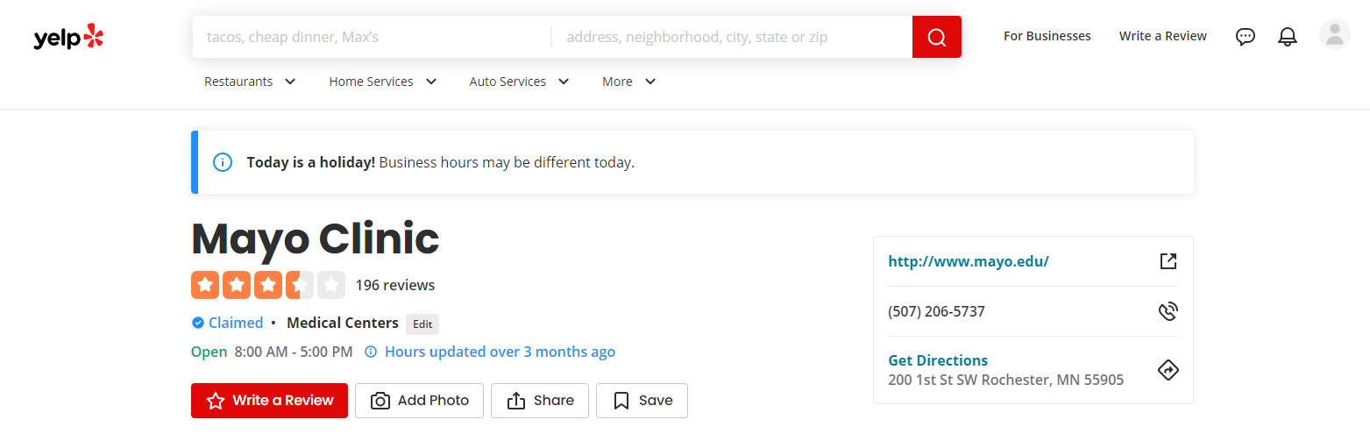
Figure 1: Mayo clinic Yelp account (Mayo clinc, 2021)

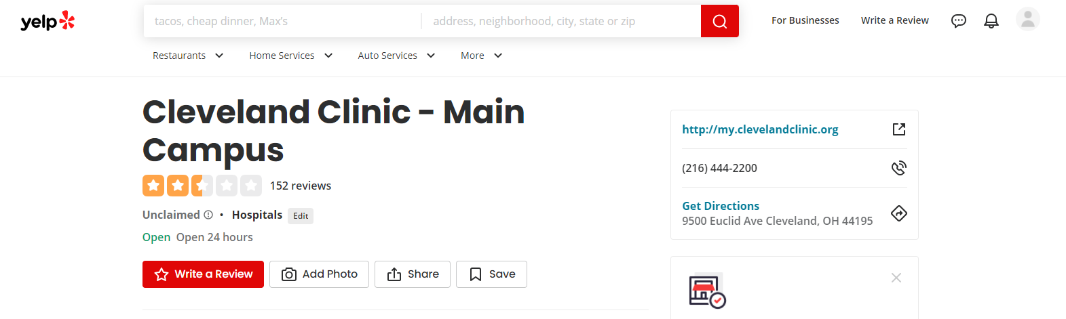
Figure 2:Cleveland clinic Yelp account (Cleveland clinic, 2021)

2.2 Indeed
On the other hand, the employee feedback from Mayo clinic and Cleveland Clinic can be found in Indeed (figure 3 & figure 4). Indeed, is a job listings site that is gathered from tens of thousands of websites, including job boards, staffing firms, trade associations, and company career pages (Hayes, 2021).
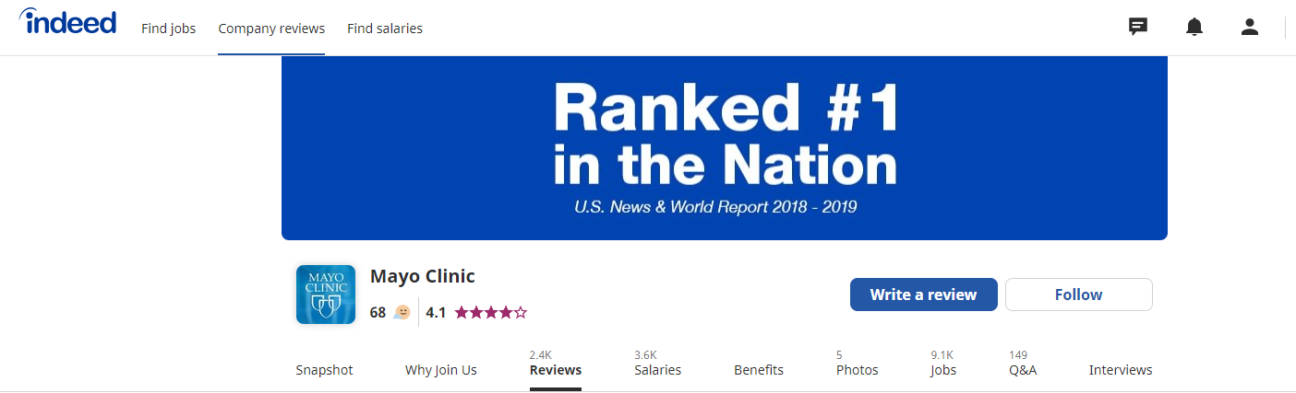
Figure 3: Mayo clinic Indeed account (Mayo clinic, 2021)

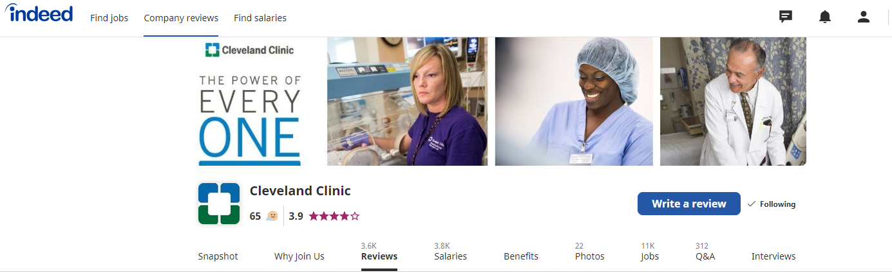
Figure 4:Cleveland Indeed account (Cleveland clinic, 2021)

2.3 Twitter
Twitter is an open service that connects people, viewpoints, ideas, and information from all around the world. Mayo Clinic official twitter followers has over 2 million people, and Cleveland Clinic official twitter followers has over 1.9 million people (figure 5 &6).
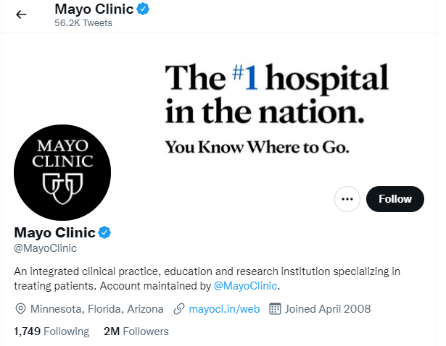
Figure 5: Mayo clinic Twitter account (Mayo clinic, 2021)

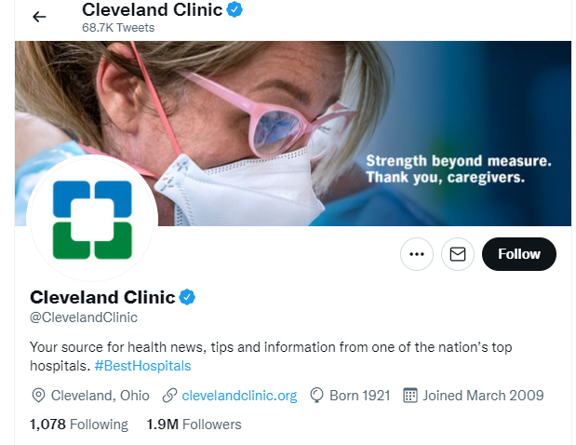
Figure 6: Cleveland clinic Twitter account (Cleveland clinic, 2021)

2.4 Tools and APIs
(Mester, 2019) quotes that “from data to information and from information to better decisions” there are typical six steps of data science project: Data collection, Data storage, Data cleaning, Data analysis, Data visualization, and Data-driven decision. (Figure 7)
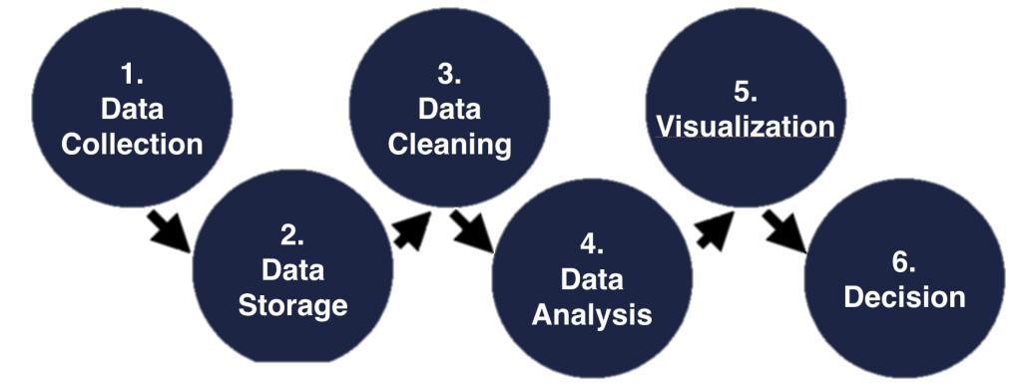
Figure 7: Steps for a Data science project (Mester, 2019)
Based on the above steps, the goal of this study is to use data from social media to analyse patient and workers at the Mayo clinic and the Cleveland clinic. In the data collection stage, this study uses Octoparse for data mining, data storage, data cleaning and other operations. I tested some web scraping software like Data miner, Scrapy, Parsehub and other for research, but Octoparse has advantage.

2.4.1: Octoparse
Octoparse is a modern web data extraction software with visual interface for both expert and beginner users to bulk extract information from websites (Octoparse, 2016). Octoparse is basically designed for non-coders to handle difficult web scraping, its guesses the desired data fields for users, saving the analyst a lot of time and effort because the analyst don’t have to manually pick data. This poses as a merit towards another web scraping tool. in addition, it automatically extracts content for practically any page and save it in a format of the analyser’s choice as clean structured data. This benefit gives great convenience when it comes to data storage and data cleaning. In data processing, a range of APIs gives more and better data processing solutions. Octoparse can also create customized APIs from any data.

Octoparse deals with virtually all the website dynamic or static, it extracts text, image URLs, links, HTML, etc. it crawls websites with indefinite scrolling, pagination, and extracts data behind login. (Figure 8)
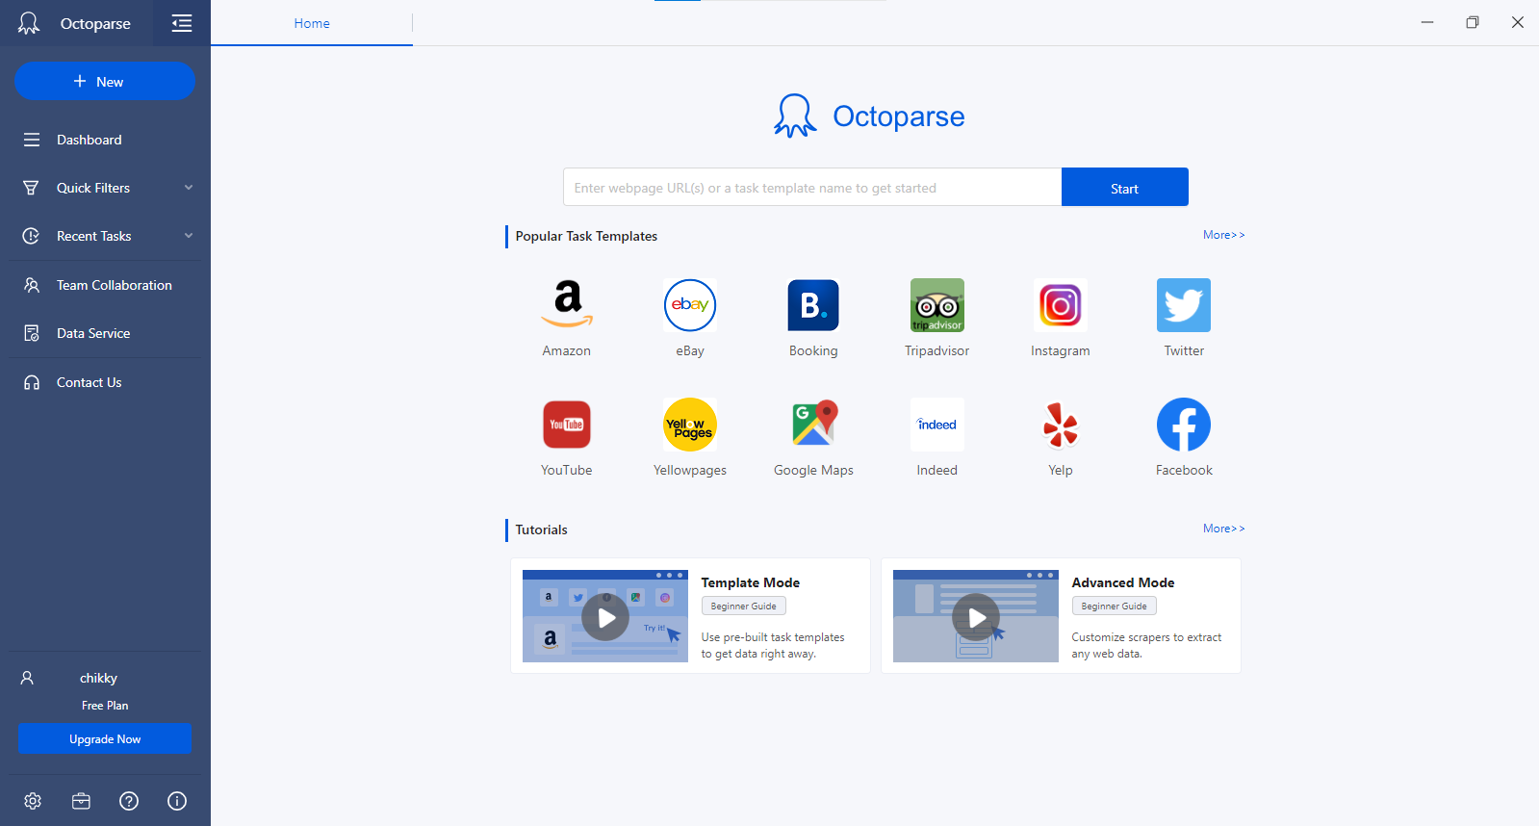
Figure 8: Octoparse interface

The fourth step in the data science project is the tableau, and sentiment analysis of twitter to visualize data. Tableau created most of the visual’s representations used in this study. Tableau is the trusted leader for analytics, and help people and organisations become more data-driven (Tableau, 2019). The advantage of tableau over traditional tools is that the visuals are faster, and the graphics generated are more appealing. As a result, study can concentrate on data rather than graph updating. Tableau also accommodates a wide range of data types. The data from social media is saved in an excel file in this scheme (xlsx file format). It’s built in visual best practises allow for unlimited visual data exploration without stopping the analysis flow (Figure 9). With accessible statistics, natural language, and smart data prep, its augmented analytics solutions let anybody from data scientist to business users uncover insights faster.
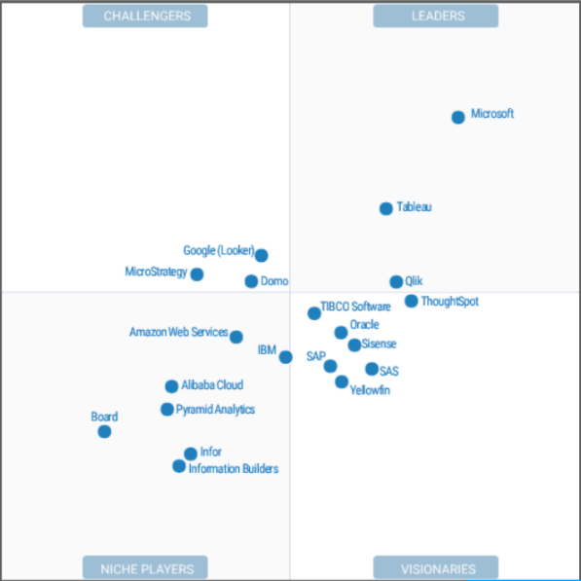
Figure 9: Tableau Global Visualisation (Dolley, 2021)

The study used Tableau and Sentiment Analysis Twitter, to analyse the data of Mayo clinic and Cleveland clinic, first we use Octoparse to crawl down the text data in Twitter, then the sentiment analysis of the text data is carried out using Sentient Analysis tool and Python. Sentiment Analysis is textual mining that finds and extract subjective data in source material, assisting businesses in understanding the social sentiment of their brand product, or service while monitoring online conversations (Gupta, 2018). Both clinics topic text is analysed. We can evaluate the keyword and the degree of affection for each clinic using the analysis. The conclusion can go into more detail about how the organisations should improve their services in each clinic. The main purpose of using Python for Sentiment analysis is to identify whether the data is positive, negative, or neutral. Sentiment Analysis tool will be used to preform analysis on textual data to help Mayo clinic and Cleveland clinic monitor brand and product sentiment in Customer and Employee’s feedback and understand their needs.

Key Results, Visualisation and Business Story Telling

Since the purpose of this research is to examine social media data for corporate narrative telling. As a result, the study substituted business story telling for the fifth and sixth steps in the data science project. This part will analyse and visualize data acquired using various techniques, as well as discuss the main findings in depth. It is necessary to study the history of the Mayo clinic and the Cleveland clinic to get insights. Let’s take a quick background of the Mayo clinic and the Cleveland clinic before I begin to describe my findings.
According to (Turner, n.d.) Doctor William Worrall Mayo is the founder pf the Mayo clinic. Dr Mayo, whose medical practise was rapidly expanding was active in Rochester political affairs and served as a mayor from 1882 to 1883. Three severe tornadoes blasted through southeast Minnesota on August 21, 1883. Mother Alfred realised that the developing city of Rochester required a hospital after the tornado. For its time, Mother Alfred's vision for a hospital is a place where active medical intervention might take place was ground-breaking. Mayo Clinic Hospital, Saint Marys Campus, established in the fall of 1889 with 27 beds. The attending surgeons were Dr Will and Dr Charlie Mayo, and the consulting physician was Dr W.W. Mayo, who was now 70 years old. The rest of the hospital personnel was made up of five Sisters. Mayo Clinic has been at the forefront of discoveries and advances throughout its history, and it continues to evolve and consolidate its position as one of the world's premier medical institutions. Mayo Clinic has made significant advancements in the following areas: Developed and implemented the concept of multi-specialty, integrated group medicine practise, developed a unified medical record, The first series of open-heart surgery was performed by him, North America's first CT scanner was introduced, developed a DNA test to identify anthrax quickly, developed a numerical-based approach for grading cancer, which was widely adopted and is still in use today.
The Cleveland Clinic Foundation on the other hand, was created in February 1921 by four Cleveland physicians who wanted to construct an organisation committed towards not simply medical treatment but also study, creativity, and physician training. During World War I, three of the four founders worked together in a US Army medical unit in France. The Cleveland Clinic Disaster of 1929, which resulted in the deaths of 123 people due to a basement fire caused by combustible x-ray film, was a catastrophe that set back the hospital's progress briefly. The Cleveland Clinic, on the other hand, rose to become one of the nation's major medical centres after WWII (Cleveland Historical team, 2019). When it initially opened its doors as a multi-specialty group practise in 1921, Cleveland Clinic was at the vanguard of modern medicine. It has evolved from a tiny outpatient clinic to the world's first fully integrated international health system. Cleveland Clinic has about 6 million patient visits every year, with over 65,000 caregivers working at over 200 locations across the world (Cleveland clinic, n.d.).
Despite all the achievement and goal each clinic poses, it is vital for a business to have a good patient/customer relationship management. (Baashar, et al., 2020) Customer relationship management (CRM) is a cutting-edge technology that aims to boost customer satisfaction, loyalty, and profitability through the acquisition, development, and maintenance of effective customer connections and interactions. let’s look at the customers reviews data from both Mayo clinic and Cleveland clinic (figure 10 & 11). Patient satisfaction is critical for the healthcare industry for multiple reasons. Foremost, positive patient experiences help ensure success in ongoing treatment and lead to greater patient recovery (Stolpe, n.d.).

3.1 Extraction of Data
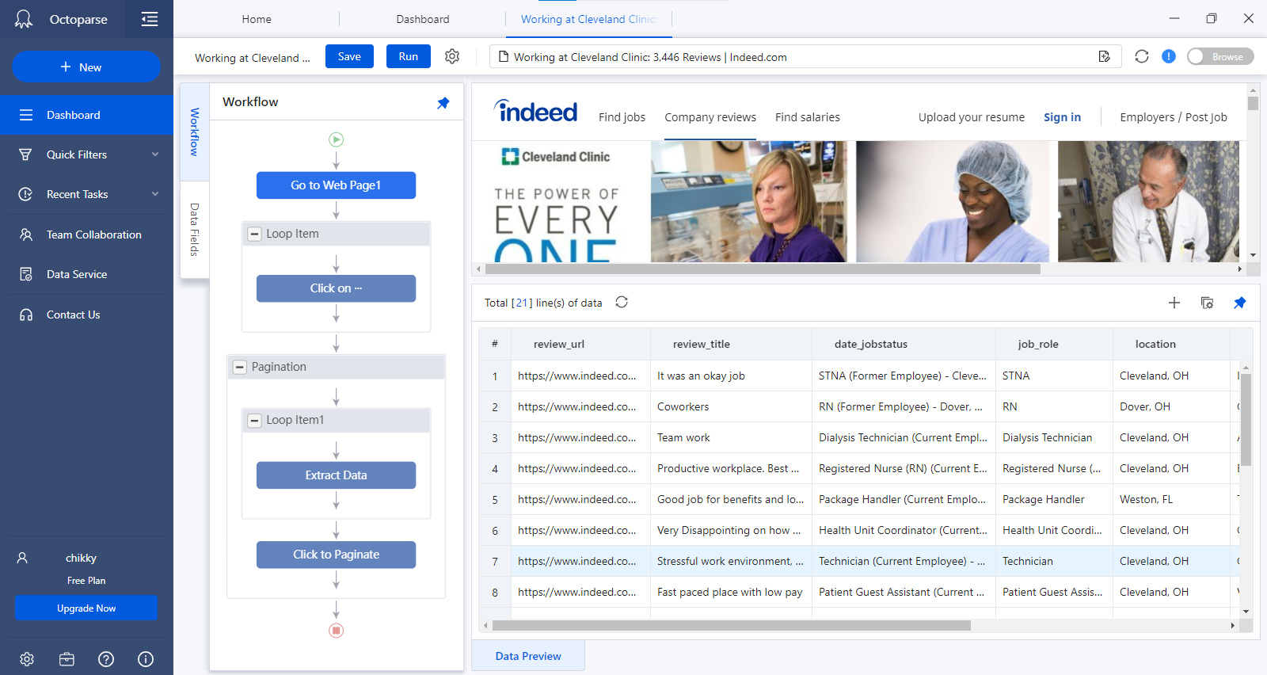
Webpage
Run
Pagination
Scrapped data
Workflow
website URL
Figure 10: Extraction of data
- Copy the URL of the website: the URL of each site for the customers and employees review was copied.
- Opening the scrapping tool: the copied URL is the pasted on the tab in the Octoparse interface and submitted. It automatically starts extracting data from the websites and produce a list of data in a table format.
- Creating workflow: you create a pattern of how you want the tool to scrape the data. this enables you see the step by step the tool will take to carry out the task.
- Pagination: the involves scrapping data from the current page to the next page. Looping the data.
- Save and Run: this enables you to save the workflow process and run it. It will pop up where you want the destination of the file you want to run to be saved.
- Download the data: after running, it will export the file to the destination provided in either excel file or comma separated value(CSV) file.
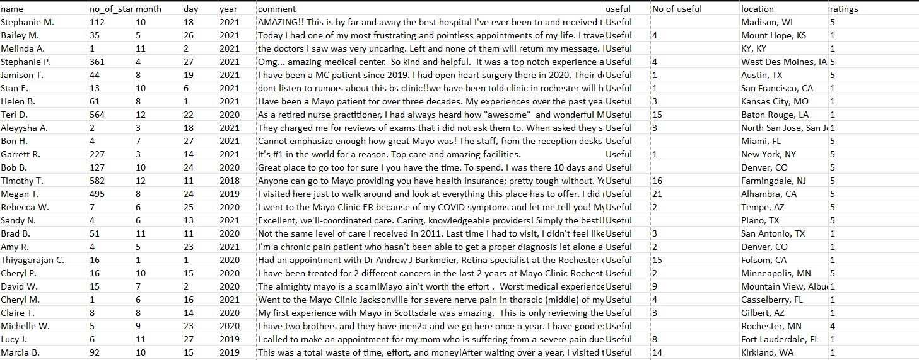
Figure 11: Customer review data from Mayo clinic
This data consists of the names of each customer, number of stars (this is like personal rating each user has with regards to how often they post on Yelp), date, comment, location, rating, and number of useful (number of people that agrees with the comment). Cleveland clinic contains the same attributes for its customer review data (Table 1).
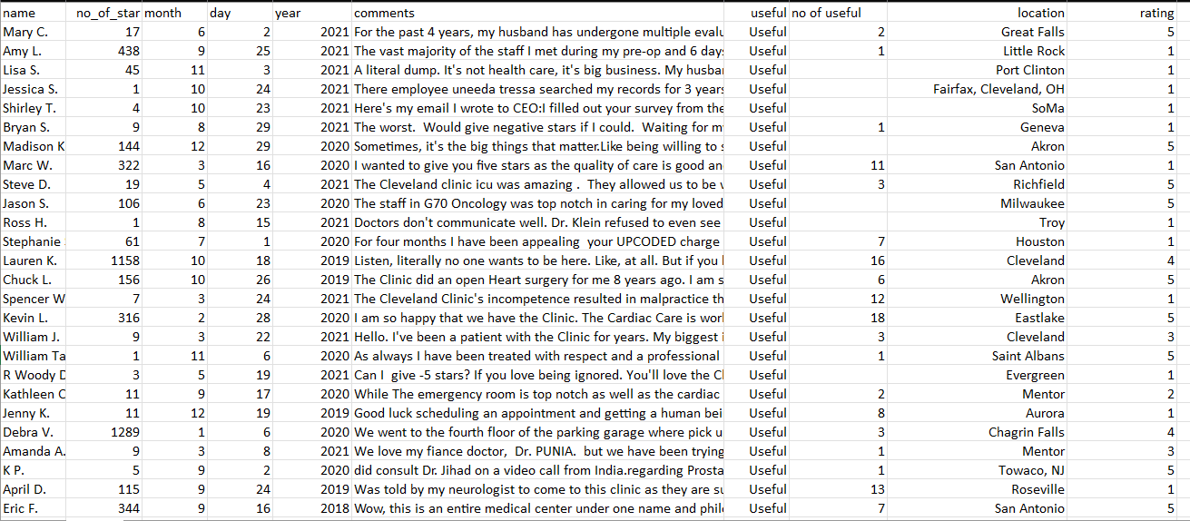
Figure 12: Customer review data for Cleveland clinic

Table 1: Customer’s Attributes
Attributes | Meaning
Name | This is having the names of each customer or patient who has given review about the clinic.
No Of Stars | This is the number of stars, and it has to do with the reviewers own personal rating
Month | The month at which the review was given
Day | The day at which the review was given
Year | The year at which the review was given
Comments | The comment given by the customer
No Of Useful | This is the number of useful, and how many people sees a comment useful to them
Location | The location at which the review was given
Rating | The rating by the customer

Employee management is easier than it sounds, and We are all aware of it. It’s the most difficult component of a managers work. However, because people are so vital to the success of their organisation, management is a skill to learn(Regan, 2021).
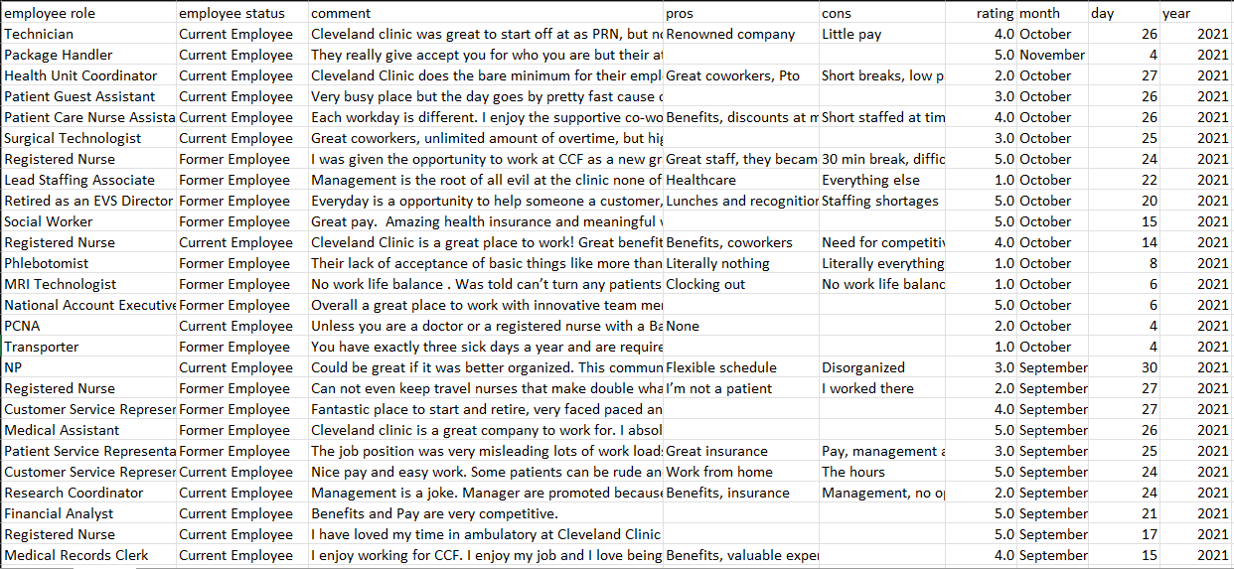
Figure 13: Cleveland clinic employee’s review data
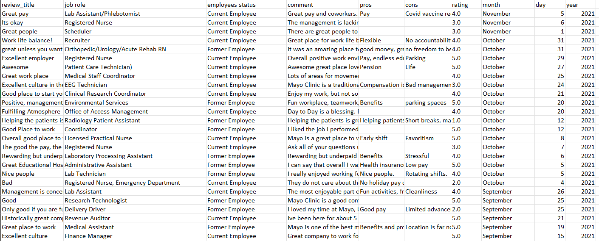
Figure 14: Mayo clinic employee’s review data
This data consists of the employee’s status (Current employee and former employee), job role, date, comment, pros, cons, rating, and review title (Table 2). Cleveland clinic contains the same attributes for its employee’s review data (figure 12 & 13).

Table 2: Employee’s Attributes
Attributes | Meaning
Review title | The title of the overall comment by the employee
Job role | The position of the employee in the given clinic
Employee’s status | This is the status of the employee if the employee is a current or past worker
Comment | The comment given by the employee
Pros | The positive or good point given by the employee
Cons | The negative or bad point given by the employee.
Rating | The rating by the employee
Month | The month at which the review was given
Day | The day at which the review was given
Year | The year at which the review was given

3.2 Customer’s Review Data Visualization
The study will visualize Mayo clinic and Cleveland clinic Customer’s review data and compare both clinics. Firstly, the study will visualize the number of rating each year for Mayo clinic and Cleveland clinic and compare them.
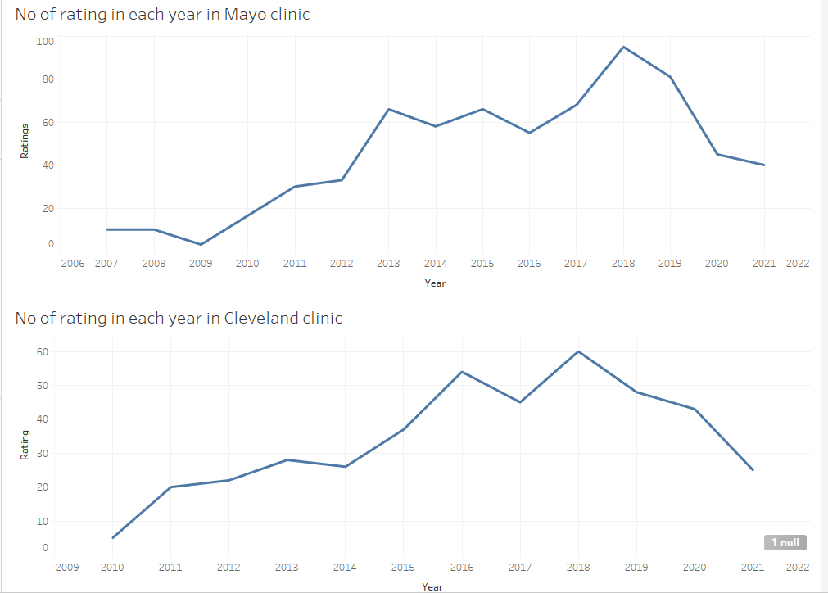
Figure 15: Number of rating each year for both clinics
The line graph represents the annual ratings given to each Mayo clinic and Cleveland clinic from 2006 to 2021 and 2009 to 2021, respectively. Mayo Clinic's rate increased from 2009 to 2013, then fluctuated after that. From 2010 to 2016, the Cleveland Clinic had a partial progressive rate, which fluctuated after that. When comparing the two-line graphs, the Mayo Clinic and Cleveland Clinic both had their best years in 2018, with scores of over 90 and 60, respectively. According to their records in 2021, Mayo Clinic has a higher rating than Cleveland Clinic, with 40 and 25 respectively (Figure 14).
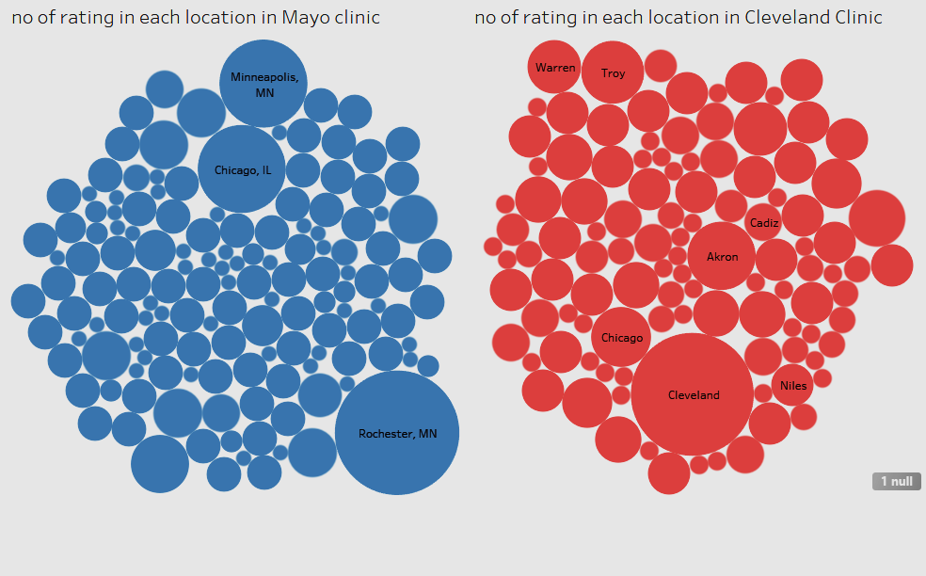
Figure 16: Number of ratings by Location
The rating in each location is shown in the bubble chart (figure 15). The top three highest-rated locations in the Mayo Clinic bubble chat are Minneapolis and Chicago, with a total of 32 ratings, and Rochester, with a score of 64. The Cleveland clinic has 13 for Akron and 11 for Troy, with Cleveland having the most at 64.
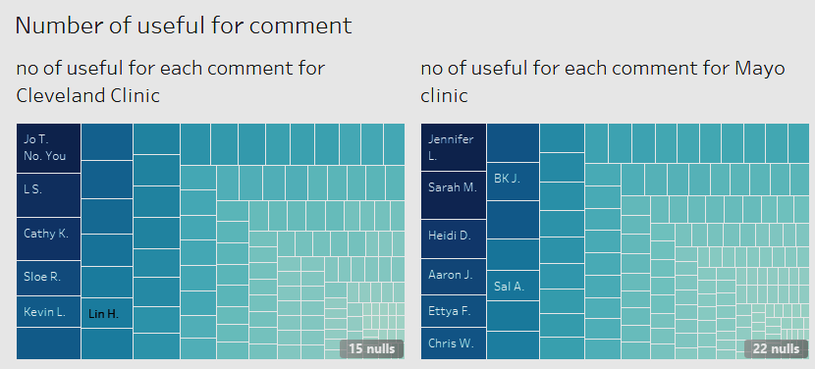
Figure 17: Number of useful in each comment
The tree maps above (figure 16) illustrate the comment for Mayo Clinic and Cleveland Clinic, which includes the names of each reviewer, their comments, and the number of useful. This includes what everyone has to say about Mayo clinic and the Cleveland clinic, the number of useful is the number of people who see reasons for what each person has to say about the clinic.

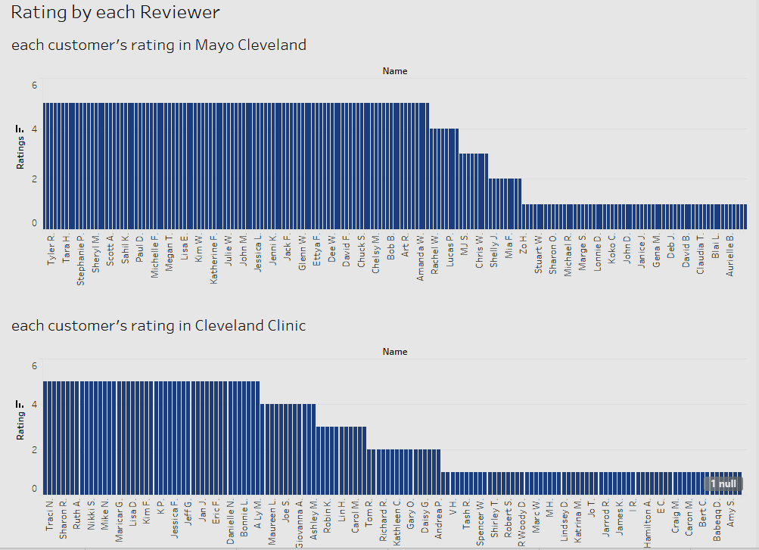
Figure 18:Rating by each Reviewer
The bar chart above (figure 17) illustrates the rating for each Reviewer in Mayo Clinic and Cleveland Clinic, as well as their names. To compare, the Mayo Clinic has more people who rank them a 5 than the Cleveland Clinic, according to the bar chart. Overall, we can see from the ratings that some people are dissatisfied with each clinic, and we can also say that Mayo Clinic and Cleveland Clinic have had their highs and lows.

3.3 Employee’s Review Data Visualization
The study will visualize Mayo clinic and Cleveland clinic Employee’s data and compare both clinics. Firstly, the study will visualize the number of records by job role for Mayo clinic and Cleveland clinic and compare them.
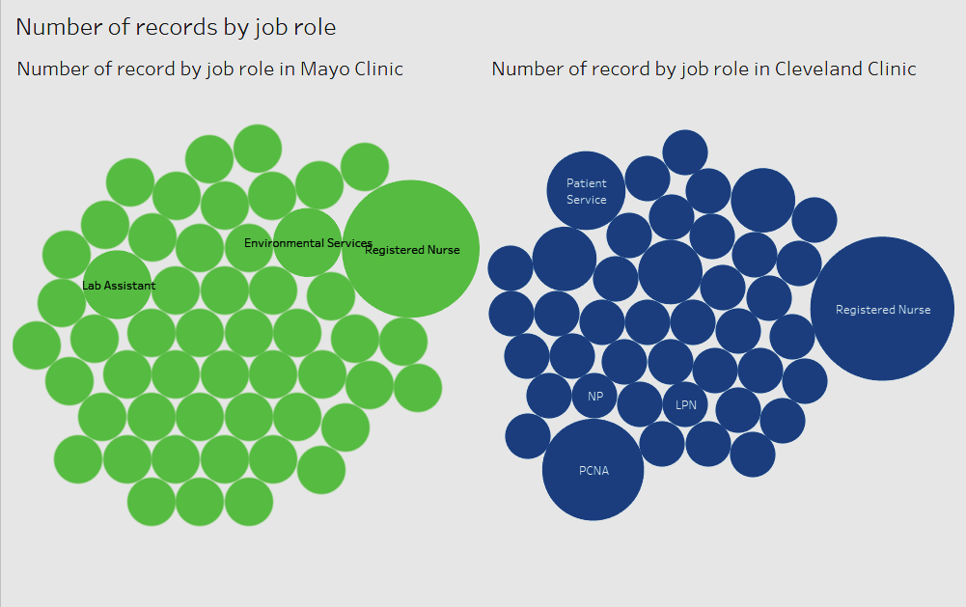
Figure 19: Number of records by job role
The number of records in each employment role at each clinic is shown in the bubble chart above (figure 18); the green bubble chart is from the Mayo Clinic; it can be determined that Registered Nurses have the most records, as does the Cleveland Clinic. Nurses make up most of the workforce, thus any successful change must include them. Furthermore, they are aware of the service's issues and, if given the chance, can provide remedies (Hart, 2015).
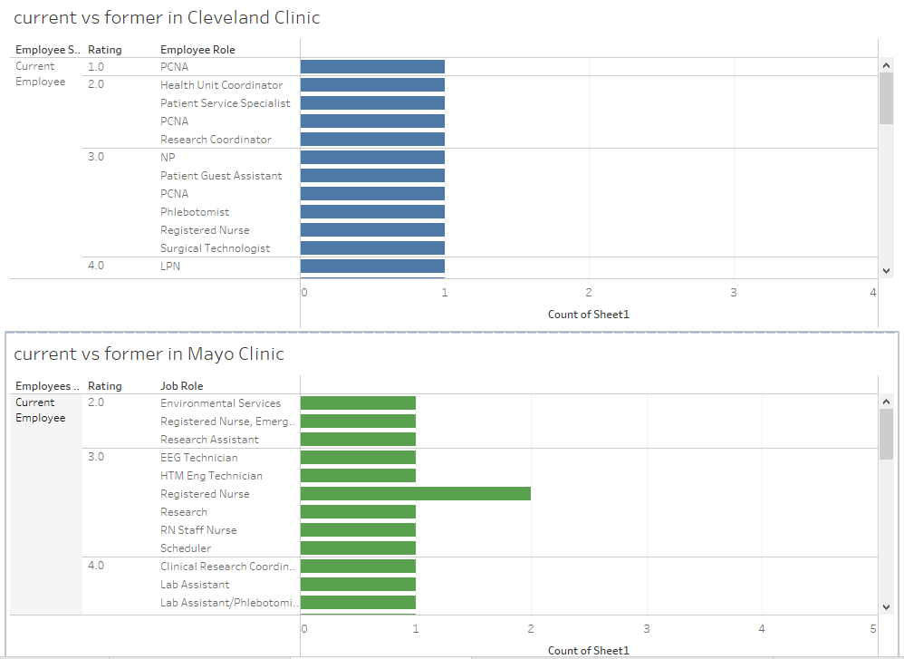
Figure 20: Current Employee vs Former Employee
The above bar graph (figure 19) demonstrates the ratings given by current and former Mayo Clinic and Cleveland Clinic employees. In every firm, there must be good and negative reviews from some people's perspective. In comparison to Mayo Clinic, former employees in Cleveland Clinic gave the highest 1-star rating. When comparing the past employee ratings for both clinics, it can be concluded that the Mayo Clinic has the highest five-star rating. In terms of current employees, Cleveland Clinic appears to have a 1Star rating record. Registered nurses appear to have given the highest ratings for Mayo clinic and Cleveland clinic, with lab assistants coming in second. (Afolabi, et al., 2018) Healthcare cannot be effective, efficient, or of high quality until organisations address the issue of healthcare employee motivation.

3.4 Sentiment Analysis
Sentiment Analysis (SA) is a field of text mining research that is still evolving. The algorithmic treatment of text's opinions, sentiments, and subjectivity (Medhat, et al., 2014). I would be analysing data from twitter on Mayo Clinic and Cleveland Clinic, using some sentiment tools and Python.

3.4.1 Using Sentiment Viz
This is a tweet sentiment visualisation programme that allows users to type in a keyword and have it pulled from Twitter, where it may be viewed in the sentiment tab, topics, Heatmap, timeline, and others.
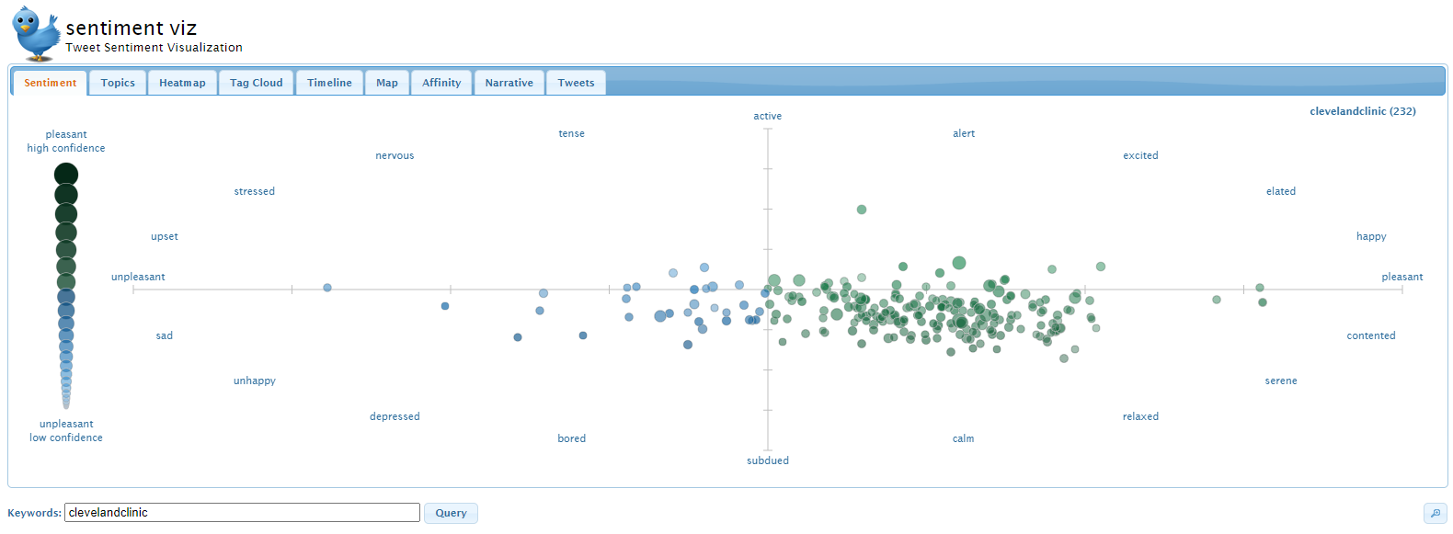
Figure 21: Cleveland clinic Sentiment tab

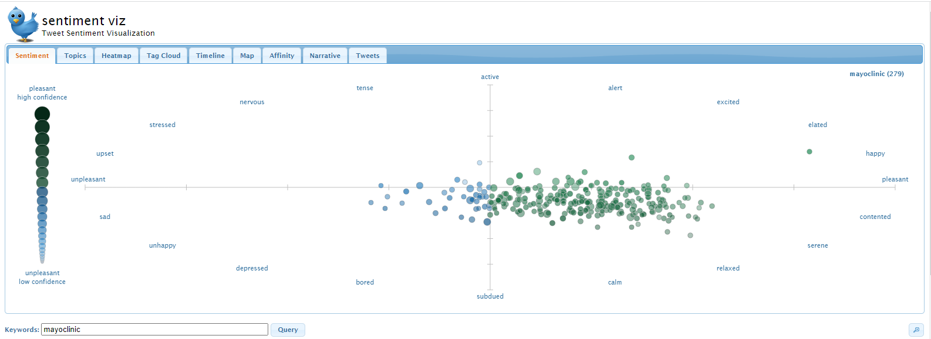
Figure 22:Mayo clinic sentiment tap

Each tweet is displayed as a circle on the Sentiment tab for each clinic, with sentiment indicating an estimate of the emotion included in the tweet's text. Unpleasant tweets are depicted on the left as blue circles, whereas pleasant tweets are depicted on the right as green circles. Active tweets are represented as brighter circles on the top, whereas sedate tweets are drawn as darker circles on the bottom. From a sentiment standpoint, Mayo Clinic slightly outperforms Cleveland Clinic, Cleveland clinic and Mayo clinic was used as keyword for the above (figure 20 &21). From the sentiment tab, if you move your mouse around it, you can be able to see details of each circle.

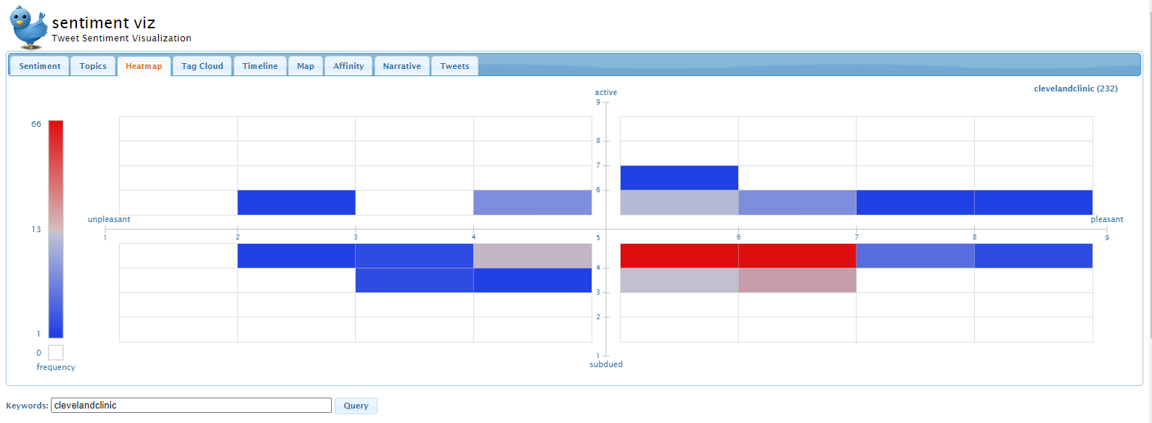
Figure 23: Cleveland clinic Heatmap

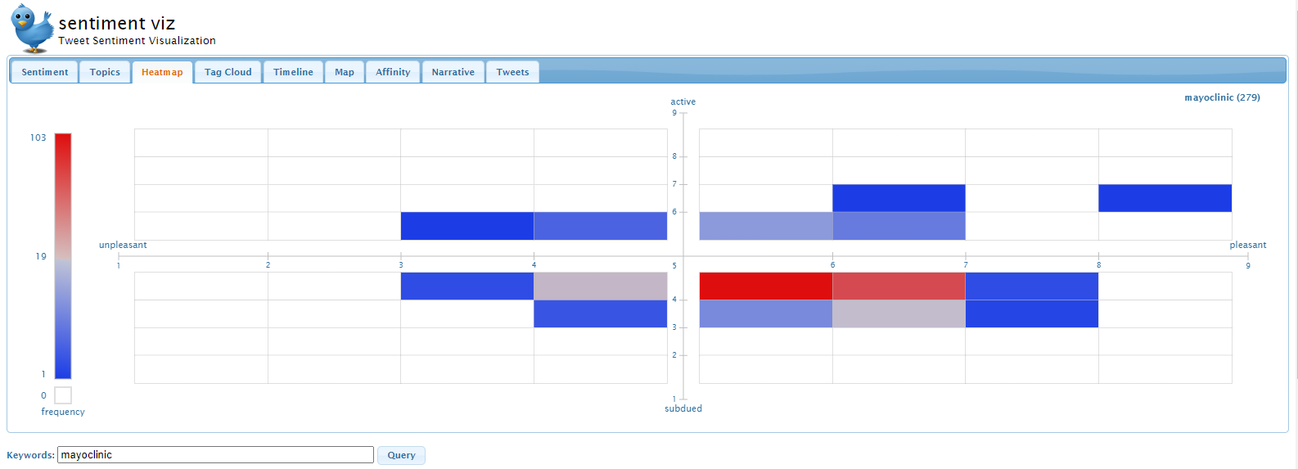
Figure 24: Mayo clinic Heatmap
Above are the heatmap tabs for Cleveland Clinic and Mayo Clinic (figure 22 &23), respectively. Sentiment is divided into an 8x8 grid by pleasure and arousal. The quantity of tweets in each grid cell is counted and used to colour the cell, with red denoting more tweets than average and blue denoting fewer tweets. There are no tweets in white cells.

3.4.2 Using Python
We'd start by importing the libraries. For this examination, we will use two libraries. The first is pandas, which is an open-source package for Python that provides simple data structures and analysis tools. The second tool we'll use is NLTK, a sophisticated Python package. Natural Language Toolkit (NLTK) is a widely used NLP library that includes a large corpus, models, and algorithms (Octoparse, 2019).
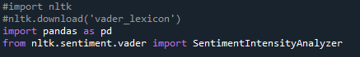
Twitter data was scraped from Octoparse and was imported to python. Mayo clinic and Cleveland clinic twitter data were called in and stored as “mayo clinic tweets” and “Cleveland clinic tweets.” Respectively in an excel file.
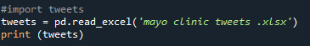
In nltk.sentiment.vader, I used a function named Sentiment Intensity Analyser. The sentiment analyser will use the NLTK method and features to implement and facilitate sentiment analysis tasks, allowing sentiment scores to be created without complex code.
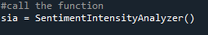

The polarity scores would be generated using the function. Negative, neural, positive, and compound are the four types of scores. We could transform the result and pot them into a "tweets" data frame by using apply() and lambda.
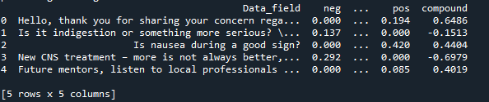
Figure 28: Mayo clinic Polarity scores

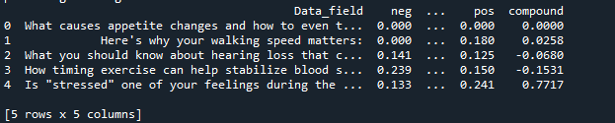
Figure 29: Cleveland clinic Polarity scores
A negative score, a neutral score, a positive score, and a compound score are all assigned to each tweet. The compound score is the result of combining the first three scores. This score might be anywhere between -1 and 1. To determine the sentiment, we usually establish a threshold for the compound score. If a tweet's compound score is more than 0.2, it is considered positive. A tweet is considered unfavourable if its compound score is less than 0.2. The tweet is neural if the compound score is between -0.2 and 0.2.
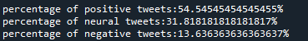

Figure 30: Mayo clinic overall score
As can be seen, 54.5 percent of tweets are favourable, with only 13.6 percent being negative. Based on the findings, it is safe to conclude that Mayo Clinic is a well-liked healthcare provider.
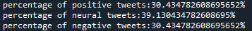
Figure 31: Cleveland clinic overall score
As can be seen, 30.4 percent of tweets are positive, with 30.4 percent being negative. Based on the findings, it is safe to conclude that Cleveland Clinic is a below average.

3.4.3 Using Voyant tools
This is a web-based reading and analysis environment for digital materials that looks right through it (Voyant tools, 2021). It was supplied with the same scraped tweeter data from Cleveland Clinic and Mayo Clinic.
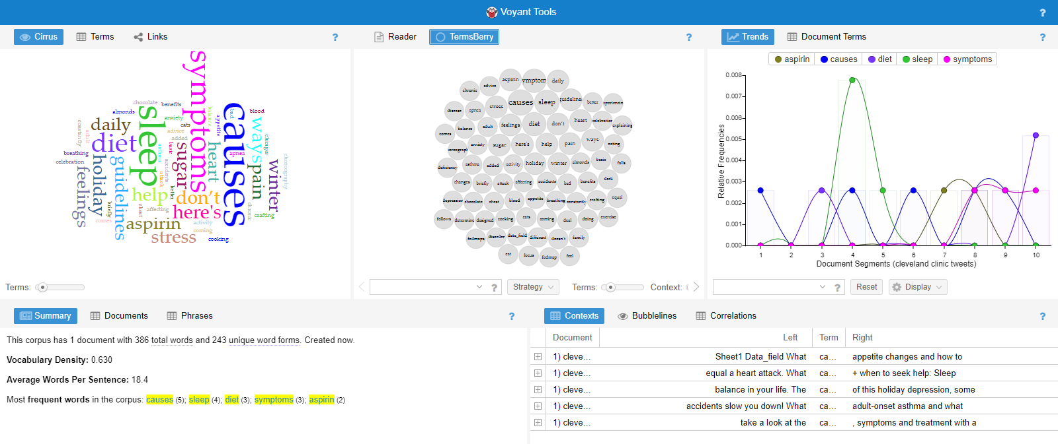
Figure 32: Cleveland Clinic Voyant Analysis
The Voyant tool Analysis is divided into five sections: top left is a tag cloud-like representation of the most frequently used words in tweets, middle is a bubble chart of the most frequently used words, top right is a wavelength line graph that shows the frequency at which each of the five most frequently used words is used and can be identified by different colours, bottom right is the context of tweets, and bottom left is the total words used and its occurrence.
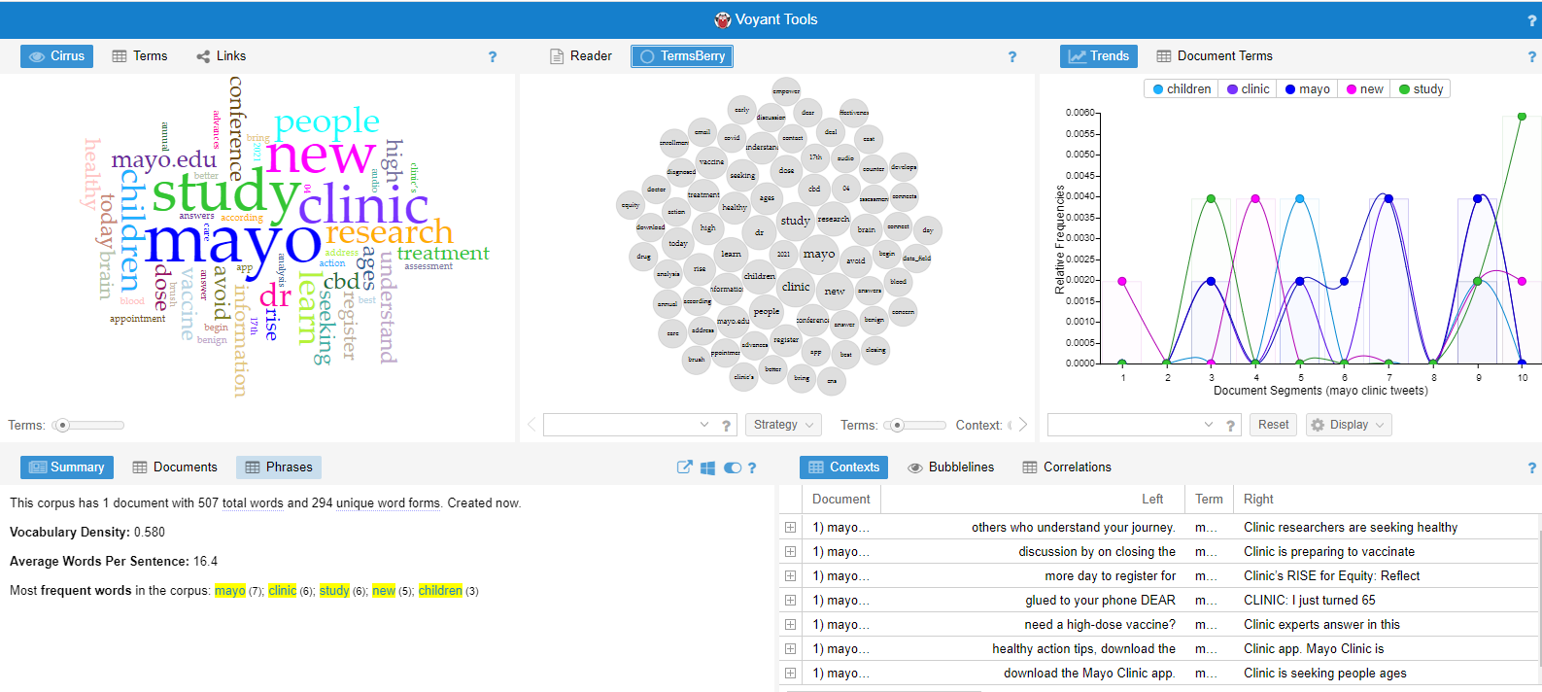
Figure 33:Mayo clinic Voyant Analysis

Conclusions, Project Limitation and Recommendation
As this study has shown social media may be utilised by parents for health consciousness or by physicians for educating patient as a full source of individual experience. As a virtually infinite source of aggregate data for large scale population studies.
In two parts, the study examines the Mayo Clinic and the Cleveland Clinic. The data were organised qualitatively and statistically based on patient reviews on social media from the analysis of Customer's management. The findings show that Mayo Clinic and Cleveland Clinic both need to improve their Customer Relationship Management (CRM) skills; there is a significant gap in CRM understanding, despite some favourable feedback. The Employees management on the other hand, it implies that the world of health-care staffing is complicated and multifaceted, and that the ramifications of staffing are far-reaching, affecting practically every area of healthcare. Mayo clinic and Cleveland clinic should discover innovative approaches to staffing that will better serve their future, harness experience and ideas from across disciplines, facilities, and locations.
Data scraping from websites was a bit tough during this research, and some sites even disallowed data scraping from their websites. It was also difficult to find a good data scraping tool that could bypass some protocols. Using Python for sentiment analysis was quiet a lot ,because the Twitter API's regulation was delayed, I had to innovate. Healthcare monitoring and analysis systems might certainly benefit from the incorporation of social media-based methodologies. As more individuals utilise social media, communication channels become progressively more scattered, and the risk of distributing false or problematic information grows in accordance.

References

Afolabi, A., Fernando, S. & Bottiglieri, T., 2018. The effect of organisational factors in motivating healthcare employees: a systematic review. British Journal of Healthcare Management, 24(12).
Baashar, Y. et al., 2020. Customer relationship management systems (CRMS) in the healthcare environment: A systematic literature review. Computer Standards & Interfaces, Volume 71, p. 103442.
Cathrine, B. A. et al., 2009. The power of social networking in medicine. Nature Biotechnology, Volume 27, pp. 888-890.
Cimiotti, J. P., Aiken, L. H., Sloane, D. M. & Wu, E. S., 2012. Nurse staffing, burnout, and health care–associated infection. Am J Infect Control, 40(6), pp. 486-490.
Cleveland clinic, 2021. Cleveland clinic. [Online] Available at: https://twitter.com/ClevelandClinic [Accessed 18 November 2021].
Cleveland clinic, 2021. Cleveland clinic main campus cleveland. [Online] Available at: https://www.yelp.com/biz/cleveland-clinic-main-campus-cleveland-2 [Accessed 18 November 2021].
Cleveland clinic, 2021. Cleveland clinic reviews. [Online] Available at: https://www.indeed.com/cmp/Cleveland-Clinic/reviews [Accessed 18 November 2021].
Cleveland clinic, n.d. Cleveland Clinic History. [Online] Available at: https://my.clevelandclinic.org/about/history [Accessed 20 November 2021].
Cleveland Historical team, 2019. Cleveland Clinic. [Online] Available at: https://clevelandhistorical.org/items/show/8 [Accessed 20 November 2021].
Dolley, R., 2021. The 2021 Gartner BI Magic Quadrant is Broken for Cognos Analytics. [Online]
Available at: https://ibmblueview.com/2021-magic-quadrant-cognos/ [Accessed 14 November 2021].
Drury, A., 2021. Social Media. [Online] Available at: https://www.investopedia.com/terms/s/social-media.asp [Accessed 31 November 2021].
Farsi, D., 2021. Social Media and Health Care, Part I: Literature Review of Social Media Use by Health Care Providers. Journal of Medical Internet Research, 23(4).
Gupta, S., 2018. Sentiment Analysis: Concept, Analysis and Applications. [Online]
Available at: https://towardsdatascience.com/sentiment-analysis-concept-analysis-and-applications-6c94d6f58c17 [Accessed 14 November 2021].
Hart, C., 2015. Nurses are by far the largest part of the workforce and any successful change must involve them. [Online] Available at: https://www.nursingtimes.net/news/policies-and-guidance/nurses-are-by-far-the-largest-part-of-the-workforce-and-any-successful-change-must-involve-them-29-04-2015/ [Accessed 29 November 2021].
Hayes, A., 2021. Indeed vs. LinkedIn: What's the Difference?. [Online] Available at: https://www.investopedia.com/articles/personal-finance/020215/indeed-vs-linkedin.asp [Accessed 20 November 2021].
Jeana, F. et al., 2011. Patient-reported outcomes as a source of evidence in off-label prescribing: Analysis of data from patients-likeme. Journal of Medical Internet Research, 13(1).
Jennie, H. K. et al., 2014. Communication about childhood obesity on twitter. American Journal of Public, 104(7), pp. 62-69.
Kotov, A., 2015. Social Media Analytics for Healthcare. In: C. K. Reddy & C. C. AggarwaL, eds. Healthcare Data Analytics. Detroit, MI: CRC Press.
Mayo clinic, 2021. Mayo clinic rochester. [Online] Available at: https://www.yelp.com/biz/mayo-clinic-rochester-12 [Accessed 18 November 2021].
Mayo clinic, 2021. Mayo clinic. [Online] Available at: https://twitter.com/MayoClinic [Accessed 18 November 2021].
Mayo clinic, 2021. Mayo clinic reviews. [Online] Available at: https://www.indeed.com/cmp/Mayo-Clinic/reviews [Accessed 18 November 2021].
Mayo Clinic, n.d. What makes care at Mayo Clinic different?. [Online]
Available at: https://www.mayoclinic.org/why-choose-mayo-clinic/what-makes-mayo-clinic-different
[Accessed 11 November 2021].
Medhat, W., Hassan, A. & Korashy, H., 2014. Sentiment analysis algorithms and applications: A survey. Ain Shams Engineering Journal, 5(4), pp. 1093-1113.
Mester, T., 2019. Data science for Business. [Online] Available at: https://data36.com/data-science-for-business/ [Accessed 13 November 2021].
Mukherjee, A. & McGinnis, J., 2007. E-healthcare: an analysis of key themes in research. International journal of pharmaceutical and healthcare marketing, 1(4), pp. 349-363.
Muoio, D., 2021. Mayo Clinic, Cleveland Clinic take top spots on U.S. News' 2021-22 Best Hospitals ranking. [Online] Available at: https://www.fiercehealthcare.com/hospitals/mayo-clinic-cleveland-clinic-take-top-spots-u-s-news-2021-22-best-hospitals-ranking [Accessed 11 November 2021].
Octoparse, 2016. User Guide. [Online] Available at: https://www.octoparse.com/doc-wf/introduction [Accessed 13 November 2021].
Octoparse, 2019. Sentiment Analysis For Hotel Reviews. [Online] Available at: https://www.octoparse.com/blog/sentiment-analysis-for-hotel-reviews [Accessed 29 November 2021].
Rebuge, A. & Ferreria, D. R., 2012. Business process analysis in healthcare environments: A methodology based on process mining. Information Systems, 37(2), pp. 99-116.
Regan, R., 2021. What is Employee Management & How to Manage Employees Effectively. [Online]
Available at: https://connecteam.com/what-is-employee-management/ [Accessed 22 November 2021].
Resis, R., 2019. Success At Cleveland Clinic And The Future Of Healthcare. [Online]
Available at: https://www.forbes.com/sites/robertreiss/2019/01/18/success-at-cleveland-clinic-and-the-future-of-healthcare/?sh=2674389a1dc5 [Accessed 11 November 2021].
Stephenson, B., 2020. What Is Yelp And How Does It Work?. [Online] Available at: https://www.lifewire.com/what-is-yelp-4685842 [Accessed 20 November 2021].
Stolpe, M., n.d. Employee Engagement in Healthcare: 5 Facts You Need to Know. [Online] Available at: https://bonfyreapp.com/blog/employee-engagement-in-healthcare [Accessed 21 November 2021].
Tableau, 2019. Why choose Tableau. [Online] Available at: https://www.tableau.com/en-gb/why-tableau [Accessed 13 November 2021].
Turner, T., n.d. HISTORY OF MAYO CLINIC. [Online] Available at: https://www.experiencerochestermn.com/mayo-clinic/history/ [Accessed 20 November 2021].
Voyant tools, 2021. Voyant tools see through your text. [Online] Available at: https://voyant-tools.org/?corpus=5d0b1c8e8613388bb7be326887821405 [Accessed 29 November 2021].
Watson, H. J., 2009. Tutorial: business intelligence–past, present, and future. Communications of the Association for Information Systems, 25(1), p. 39.
Wyner, J., n.d. How One Organization Supports Culture with Internal Communications Platform. [Online] Available at: https://bonfyreapp.com/blog/one-organization-supports-culture-communications-platform [Accessed 21 November 2021].

